Trade of Metal Fabrication
Module 4: | Structural Steel Fabrication
Unit 8: | Column Base
 | Phase 2

Table of Contents
List of Figures 4
List of Tables 4
Document Release History 5
Module 4 – Structural Steel Fabrication 6
Unit 8 – Column Base 6
Learning Outcome: 6
Key Learning Points: 6
Training Resources: 7
Key Learning Points Code: 7
Solid Geometry 8
Introduction 8
Horizontal and Vertical Planes 8
First Angle Orthographic Projection 9
Example of First Angle Orthographic Projection 11
End Views in First Angle Projection 13
Third Angle Orthographic Projection 16
Self Assessment 20
Index 21

List of Figures
Figure 1 - Two Orthogonal Planes H.P. and V.P. 9
Figure 2 - Object Placed between the V.P. and the H.P. 10
Figure 3 - Front View and Plan Drawn onto the V.P. and the H.P. 11
Figure 4 - Front View and Plan in First Angle Orthographic Projection 11
Figure 5 - Pipe Clip 12
Figure 6 - First Angle Projection of the Pipe Clip 12
Figure 7 - Dimensioned Drawing of the Pipe Clip Drawn on an A3 Sheet of Paper 13
Figure 8 - Orthographic Projections of Solids 13
Figure 9 - Adding a Second V.P. 14
Figure 10 - Three First Angle Views Obtained from Figure 9 14
Figure 11 - Five Views in First Angle Orthographic Projection 15
Figure 12 - Pictorial View of a Mounting Rubber 15
Figure 13 - Example of a Three-View First Angle Orthographic Projection 16
Figure 14 - Basic Theory of Third Angle Projection 17
Figure 15 - H.P. and V.P. with the Object Removed 18
Figure 16 - Front View and Plan on the H.P. and V.P. 18
Figure 17 - Adding a Second V.P. 19
Figure 18 - Three Views in Third Angle Projection 19

List of Tables

Document Release History
Date | Version | Comments
02/02/07 | First draft
13/12/13 | SOLAS transfer

Module 4 – Structural Steel Fabrication

Unit 8 – Column Base
Duration – 10 Hours

Learning Outcome:
By the end of this unit each apprentice will be able to:
- Mark out, oxy/fuel cut, drill, assemble, tack and weld a column base
- Read and interpret 1st and 3rd angle orthographic projection
- Identify material sections most common to structural fabrication
- Describe units of measurement used in steel fabrication

Key Learning Points:
Sk Rk | Measurement and marking out oxy/fuel cutting/drilling/assembly.  (For more information see Module 3 Unit 4 and Module 2 Unit 2).
Rk D | 1st and 3rd angle orthographic projection – sections – use of symbols.
Rk | Identification of most common structural sections –steel fabrication.  (For more information see Module 4 Unit 1).
Sc Rk | Structural forms – their production and properties.  (For more information see Module 4 Unit 1).
Sc Rk | Mechanical handling – safety precautions – lifting and turning techniques – lifting aids.  (For more information see Module 4 Unit 1).
Sk Rk | Tools and machinery used in structural steel fabrication.
Sk Rk | Identification of different fasteners used in structural fabrication.  (For more information see Module 4 Unit 1).
Rk | Structural fabrication uses in industry.  (For more information see Module 4 Unit 1).
Sk Rk | Minimum pitch and edge distance.  (For more information see Module 4 Unit 1).
H | Safety standards and precautions –manual handling of materials, oxy/fuel cutting, drilling and welding.  (For more information see Module 4 Unit 1).
P | Communication, initiative, work planning, safety awareness.

Training Resources:
- Apprentice toolkit
- Standard fabrication workshop and equipment P.P.E.
- M.M.A. welding plant and consumables
- Pillar drill
- Drawing equipment
- Materials as stated on drawings

Key Learning Points Code:
M = Maths D= Drawing RK = Related Knowledge Sc = Science
P = Personal Skills Sk = Skill H = Hazards

Solid Geometry

Introduction
Many technical drawings will be orthographic projections. These allow a draughtsman to show the exact form, shape and sizes of solid objects. If you wish to learn how to construct good technical drawings, learn the theory underlying orthographic projection.

Horizontal and Vertical Planes
If a horizontal plane is crossed by a vertical plane, they must be at right angles to each other - they are orthogonal to each other. Orthographic projection is based upon orthogonal planes. A horizontal plane is usually called an H.P. A vertical plane is usually known as a V.P. Figure 1 shows an H.P. crossing a V.P. These planes form four angles - known as the First angle, the Second angle, the Third angle and the Fourth angle. In orthographic projection, only the First and Third angles are used.

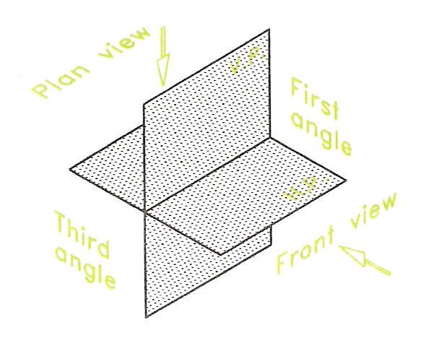
Figure 1 - Two Orthogonal Planes H.P. and V.P.

First Angle Orthographic Projection
Figure 2 to Figure 4 describe the theory of First angle projection.

- The object to be drawn is placed on the H.P. in the First angle - Figure 2.
- Looking at the object directly from the front, what can be seen is drawn onto the V.P. This is a Front view. Looking at the object directly from above, gives a Plan.
- The object is removed from its place between the two planes - Figure 3.
- The H.P. is rotated through 90 degrees to lie in line with the V.P. This gives a Front View and Plan of the object in First angle projection - Figure 4.

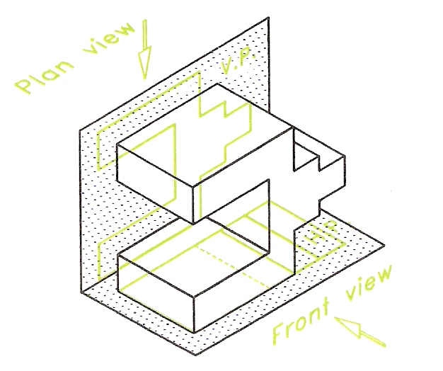
Figure 2 - Object Placed between the V.P. and the H.P.

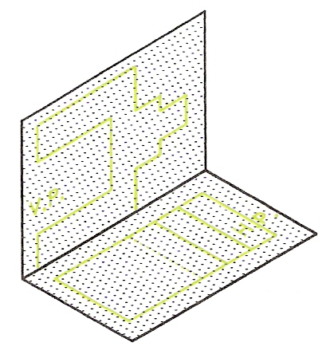
Figure 3 - Front View and Plan Drawn onto the V.P. and the H.P.

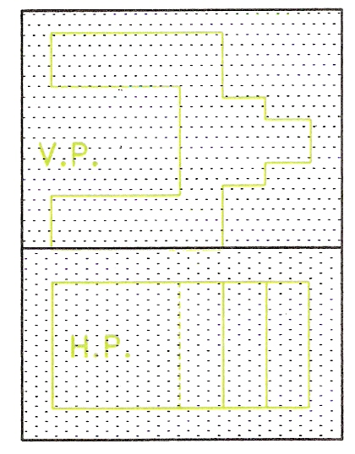
Figure 4 - Front View and Plan in First Angle Orthographic Projection

Notes:
- Views are often known as elevations. The word view is to be preferred because it is the word used in ISO and British Standards.
- The Plan is drawn below the Front view.
- Because of the way in which the two views were obtained from a V.P. and an H.P., they must be vertically in line with each other.

Example of First Angle Orthographic Projection
- Figure 5 is a 'pictorial' view of a pipe clip made from plastic for clipping a pipe to a wall.
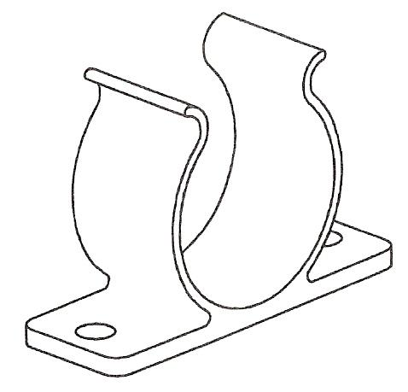
Figure 5 - Pipe Clip

- Figure 6 is a Front view and a Plan in First angle projection of the pipe clip.
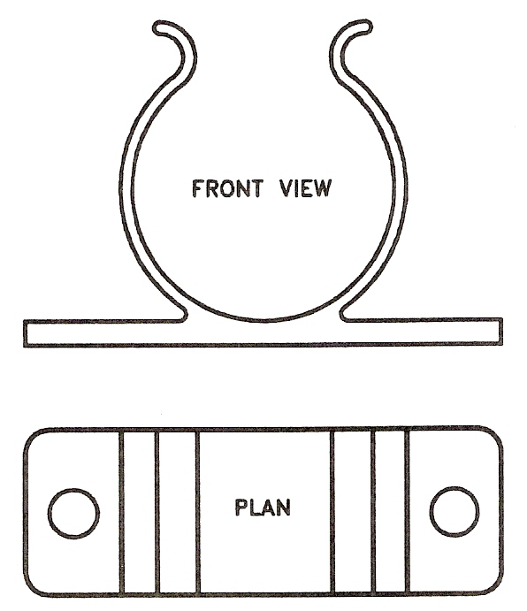
Figure 6 - First Angle Projection of the Pipe Clip
- Figure 7 shows the orthographic projection of the pipe clip in the form the orthographic projection would be drawn for use by those engaged in making the clip. Many more drawings of this type appear later in this book.
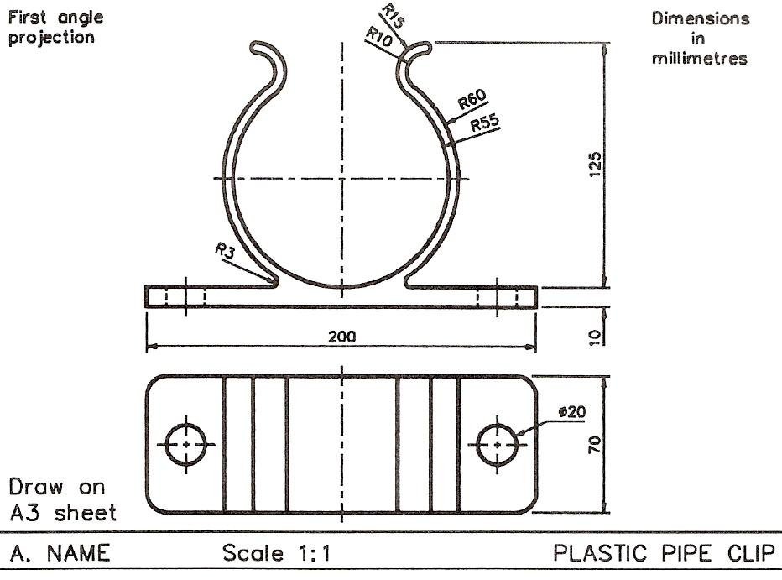
Figure 7 - Dimensioned Drawing of the Pipe Clip Drawn on an A3 Sheet of Paper

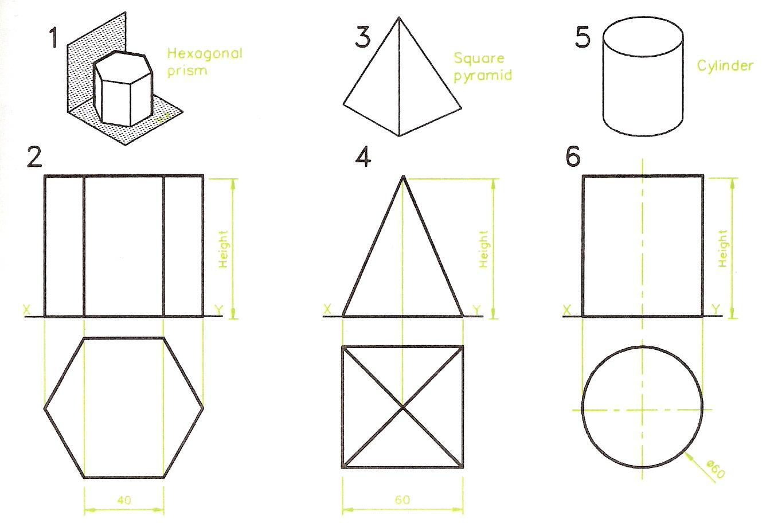
Figure 8 - Orthographic Projections of Solids

End Views in First Angle Projection
- Figure 9 shows the result of adding a second V.P. to the H.P. and V.P. shown in Figure 1 and projecting what is seen from looking in the direction labelled End view in Figure 9.
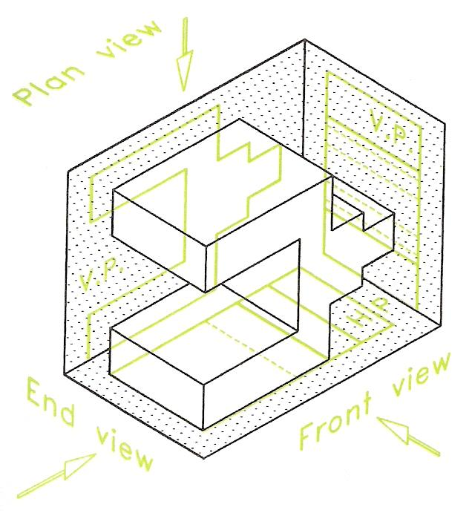
Figure 9 - Adding a Second V.P.

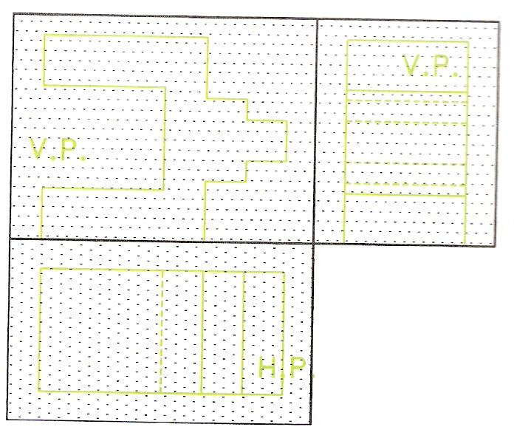
Figure 10 - Three First Angle Views Obtained from Figure 9
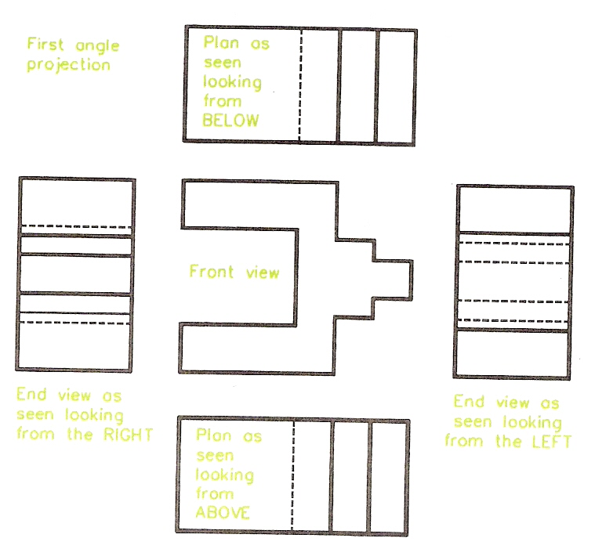
Figure 11 - Five Views in First Angle Orthographic Projection

- Figure 10 shows the results of rotating both V.P.s so that they lie flat with the H.P. The result is that a new view - an End view has been added to the Front view and Plan.
- Figure 10 shows how an end view can be included in a First angle orthographic projection. Taking the theory further, Figure 11 shows that it is possible, by adding further imaginary V.P.s and H.P.s to include two End views and two plans in a First angle projection. Note that the term 'Plan' is used here in a different sense to its normal meaning. In orthographic projection a Plan can be drawn by looking upwards at an object from below.
- Figure 12 is a pictorial view of a mounting rubber from a motor car engine and Figure 13 is an example of a First angle orthographic projection which includes a Front view and End view and a Plan.
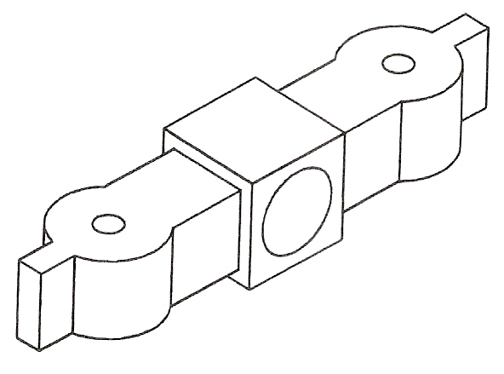
Figure 12 - Pictorial View of a Mounting Rubber
Notes:
- The End view on the right is obtained by looking from the left.
- The End view on the left is obtained by looking from the right.
- A Plan can be obtained by looking from above, in which case the Plan will be below the Front view.
- A Plan can be obtained by looking from below, in which case the Plan will be above the Front view.
- A Front view can also be obtained by looking from the back. The term 'Front view' in orthographic projections has a different meaning to the usual meaning of the term.

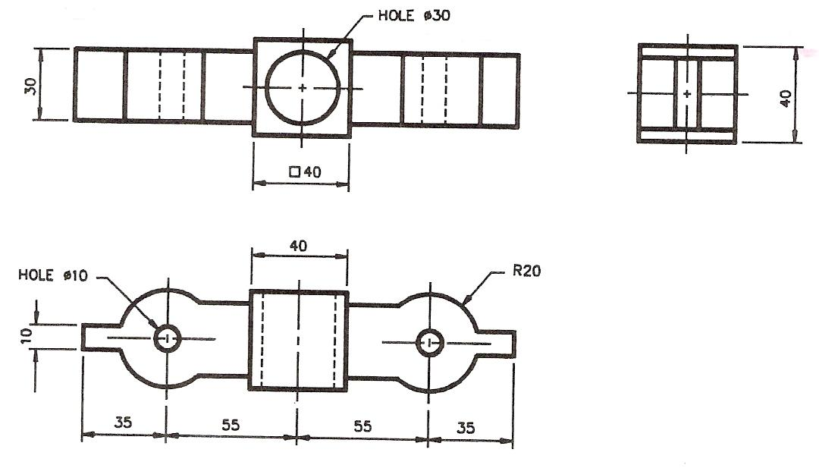
Figure 13 - Example of a Three-View First Angle Orthographic Projection

Third Angle Orthographic Projection
Third angle orthographic projection was mentioned on page 8. Although nearly all the orthographic projections in this book will be in First angle, it is important the reader can recognise Third angle projections when he/she comes across them. The theory of planes behind Third angle projection is the same as for First angle, except the object to be drawn is placed in the Third angle of the H.P. and V.P. crossing planes. This results in the planes being placed in front of the object being drawn.

Figure 14 shows an object placed in the Third angle formed by an H.P. and a V.P. and the directions of viewing to see the Front view and Plan. In Figure 15, the object has been removed, leaving the outlines of a Front view on the V.P. and of a Plan on the H.P. When one of the two planes is rotated through 90 degrees so that both planes are lying flat together, the result is as shown in Figure 16 - with the Plan above the Front view.

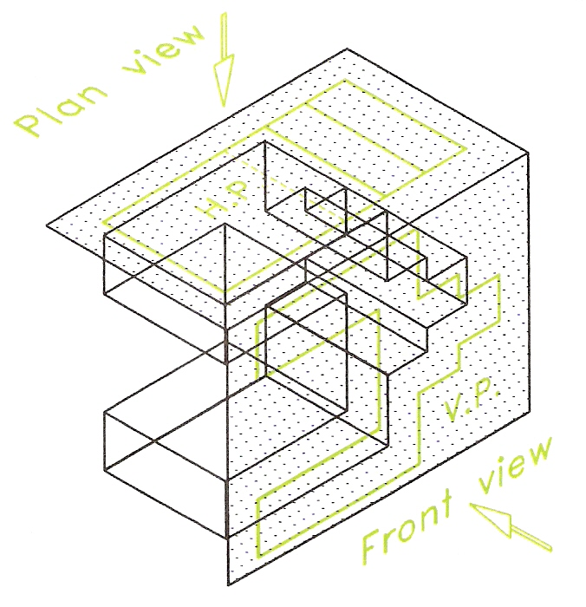
Figure 14 - Basic Theory of Third Angle Projection
When an additional V.P. is added to allow an End view to be drawn as shown by Figure 17 and the three planes rotated to all be in the same flat plane, the results are as given in Figure 18. As can be seen in Figure 18, the End view as seen from the left is drawn on the left of the Front view.
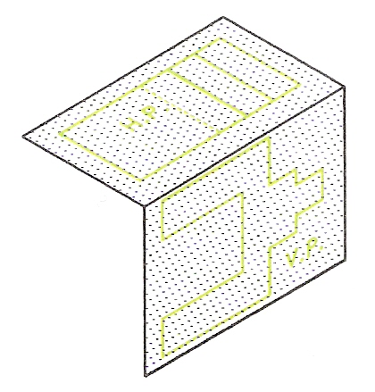
Figure 15 - H.P. and V.P. with the Object Removed

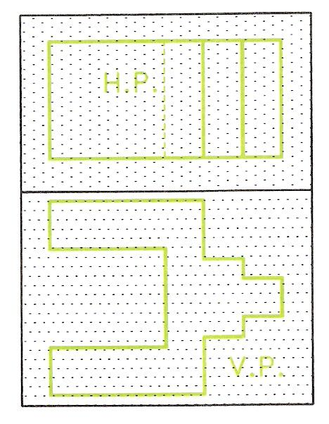
Figure 16 - Front View and Plan on the H.P. and V.P.
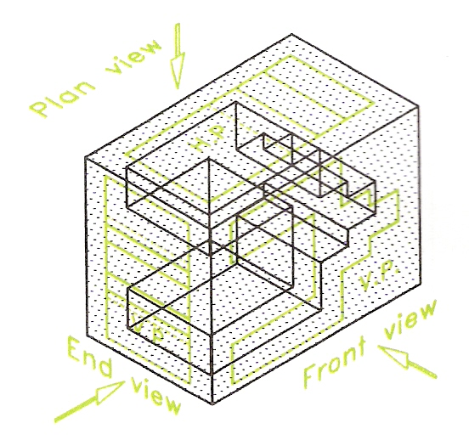
Figure 17 - Adding a Second V.P.

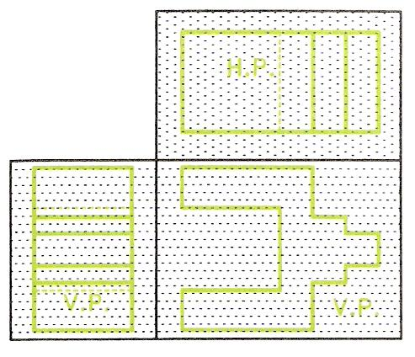
Figure 18 - Three Views in Third Angle Projection

Thus in Third angle orthographic projection:
- The Plan is above the Front view.
- An End view as seen when looking from the left is drawn to the left of the Front View.
- An End view as seen when looking from the right of the Front view is drawn to the right of the Front view.
- The theory of orthographic projection is based upon the object to be drawn being placed in space with a horizontal plane (H.P.) below the object and other planes - vertical (V.P.) and inclined - being placed behind, to the sides of or at angles to, the object.
- Two angles of orthographic projection are in use - First angle and Third angle projection.
- In orthographic projection the Front view is not necessarily the front of the object, but the view chosen to give the best information about the object as seen in a Front view.
- In First angle projection:
a) The Plan is placed below the Front view.
b) An End view as seen from the left is placed on the right of the Front view.
c) An End view as seen from the right is placed on the left of the Front view.
d) The front faces of End views and Plans face outwards away from the Front view.
- In Third Angle projection:
a) The Plan is placed above the Front view.
b) An End view as seen from the left is placed on the left of the Front view.
c) An End view as seen from the right is placed on the right of the Front view.
d) The front faces of End views and Plans face inwards towards the Front view.
- Other views are possible, e.g. a Plan as seen from below; a Front view as seen from behind.
- A truncated solid is one that has been cut by a plane and had part of the solid removed.
- When laying out drawings in orthographic projections:
a) Drawing sheets may be placed vertically 'portrait' layout, or horizontally - 'landscape' layout.
b) Add a border (margin) line all around the sheet of drawing paper:
- 10 mm for A4 sheets.
- 15 mm for A3 sheets.
- 20 mm for A2 sheets.
- Include a title block with printing, mostly in capital letters:
- 6 mm high for A4 sheets.
- 8 mm high for A3 sheets.
- 10 mm high for A2 sheets.

Self Assessment
Questions on Background Notes – Module 4.Unit 8

No Suggested Questions and Answers.

Index

F
First Angle Orthographic Projection
Example of First Angle Orthographic Projection, 12
S
Self Assessment, 21
Solid Geometry, 9
End Views in First Angle Projection, 14
First Angle Orthographic Projection, 10
Horizontal and Vertical Planes, 9
Introduction, 9
Third Angle Orthographic Projection, 17

